Name:
Regents Earth Science
HR Diagram Lab
Lab Day: Lab Period:
Lab Instructor:

Today you will be making the Hertsprung- Russel Diagram using Microsoft Excel. This allows astronomers to classify stars into groups. The two axis for this graph will be Temperature and Magnitude.

You will need to log on to a computer. Once you’ve done this open the student share drive. Find the Earth Science folder and the Lab folder inside that. Open the excel file called Stars. Save this now to your personal H: drive Fill in the empty cells according to the list that follows.

Main Sequence |  |  |  | Giant stars
Star | Temperature | Magnitude |  | Star | Temperature | Magnitude
Bellatrax | 18000 | -2.0 |  | Capella | 6000 | -0.6
Regulus | 12000 | -0.6 |  | Pollux | 4650 | 0.8
Spica | 19500 | -2.0 |  | Arcturus | 4500 | -0.3
Beta Centauri | 21000 | -3.0 |  | Aldebaran | 3900 | -0.2
Achernar | 16500 | -3.0
Beta Tauri | 12000 | -2.0
Beta Crucis | 21000 | -4.6 |  | Super Giant
Alpha Crucis | 19500 | -4.0 |  | Star | Tempertature | Magnitude
Vega | 9750 | 0.5 |  | Rigel | 12250 | -6.8
Castor | 9250 | 0.9 |  | Deneb | 9000 | -6.9
Beta Carinae | 9750 | -0.4 |  | Canopus | 7100 | -3.1
Sirius A | 9250 | 1.5 |  | Antares | 3300 | -4.5
Formalhaut | 8500 | 2.0 |  | Betelgeuse | 3200 | -5.5
Altair | 7750 | 2.2
Procyon A | 6500 | 2.6
Alpha Centauri A | 5750 | 4.4 |  | White Dwarfs
Sun | 5750 | 4.9 |  | Star | Tempertature | Magnitude
Tau Ceti | 4750 | 5.7 |  | Sirius B | 8100 | 11.4
Epsilon Eridani | 4500 | 6.1 |  | Procyon B | 6500 | 13.1
Epsilon Indi | 4250 | 7.0 |  | Eridani B | 10000 | 11.1
Cygni A | 3800 | 7.5 |  | van Maanen's | 13000 | 14.2
Cygni B | 3700 | 8.0
Alpha Centauri B | 3900 | 5.8
Kapteyn's Star | 3400 | 11.2
Lacaille 8760 | 3200 | 8.8
Lacaille 21185 | 3000 | 10.5
Bernard's Star | 2600 | 13.2
Ross 614A | 2500 | 13.3
Kruger 60B | 2500 | 13.4
Ross 248 | 2500 | 14.7

Once this has been accomplished. You can begin constructing the HR Diagram. Follow these steps and you should be okay.
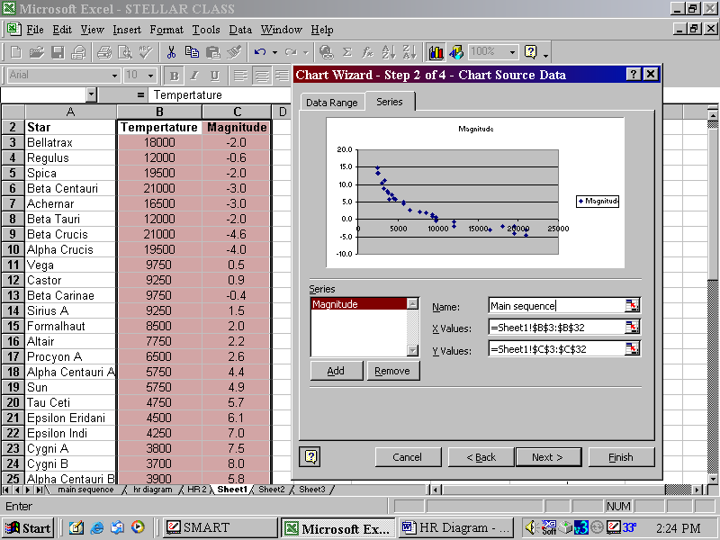
- Highlight the temperature and magnitude columns for just the main sequence stars.
- Click on the chart wizard icon in the menu bar
  - Select XY scatter and click next
- Click on the Series tab on the top of the next window
  - Name this series “Main Sequence”
- Now add a series
  - Name it “Giant Stars”
  - Define the x values by clicking on the little red white and blue box.
    - Now highlight the temperatures only on the original sheet under the giant star category.
  - Define the y values by clicking on the little red white and blue box.
    - Now highlight the magnitude only on the original sheet under the giant star category.
- Add another series
  - Name it “Super Giant Stars”
  - Define the x values by clicking on the little red white and blue box.
    - Now highlight the temperatures on the original sheet under the super giant star category.
  - Define the y values by clicking on the little red white and blue box.
    - Now highlight the magnitude on the original sheet under the super giant star category.
- Add another series
  - Name it “Dwarfs”
  - Define the x values by clicking on the little red white and blue box.
    - Now highlight the temperatures on the original sheet under the dwarf star category.
  - Define the y values by clicking on the little red white and blue box.
    - Now highlight the magnitude on the original sheet under the super dwarf category.
- Click next
  - Fill in chart title as “HR Diagram (your name)”, Name the x & y axis also.
- Save as a new sheet

Editing the graph.
- right click in the gray background.
  - Format plot area
    - Fill effects
      - 2 color
      - vertical shading style
      - Color 1 – blue
      - Color 2 – red
      - Pick upper left variant
- right click on the x axis – format x axis
  - go to the scale tab
    - check the x crosses at max box
    - check “values in reverse” order box
- right click on the y axis
  - go to the scale tab
    - check the reverse order box
    - check the x crosses at max box

Print your data & graph. Staple this on to your report.

Questions:
What is the relationship between temperature and magnitude for stars on the main sequence?

What would be the magnitude of a star with a temperature of 25,000 on the main sequence?

How can we tell that red giant stars are very large stars, from their position in the HR diagram?

Why do stars have different colors?

Why does a star leave the main sequence (you will need to look this one up)?

Draw a flow chart showing the fate of white dwarf, main sequence, and giant/supergiant stars.

