Name:
Regents Earth Science
Humidity, Dew-point & Cloud Base Lab
Lab Day: Lab Period:
Lab Instructor:

Introduction:
As air rises there is less atmosphere above it, so there is less pressure on it and the air molecules can spread out. As they spread out, they take their heat with them. Imagine a cubic meter rising with the air. As the air expands, there will be fewer molecules in the cube, but more importantly for this lab, there will be less HEAT in the cube which will cause a drop in the temperature. The expansion of the air causes the temperature to drop, though no heat is actually taken from the air. Temperature changes that occur due to expansion or contraction and without gain or loss of heat are called adiabatic temperature changes. Normally as air rises in the lower atmosphere the temperature drops at a rate of 10ºC for each kilometer it rises. This is known as the Dry Adiabatic Lapse Rate.
When the air spreads out (as it rises) it opens up space which more water molecules can fill, allowing more water molecules to evaporate into the air than would have at a lower altitude. This lowers the dewpoint by a rate of about 2ºC for each kilometer of rise. This is known as the dewpoint lapse rate.
You’ve already learned that when air is cooled below the dewpoint, condensation exceeds evaporation and the amount of liquid water increases as dew or cloud/fog droplets form and grow. As air rises, the temperature drops 10ºC for each kilometer, and the dewpoint drops 2ºC per km. If this goes on long enough, the falling temperature will eventually catch up to the falling dewpoint. When this happens, condensation will exceed evaporation and tiny droplets of liquid water will form in the air. We call a mass of tiny water droplets in the air a______________ (or ________ if at ground level).
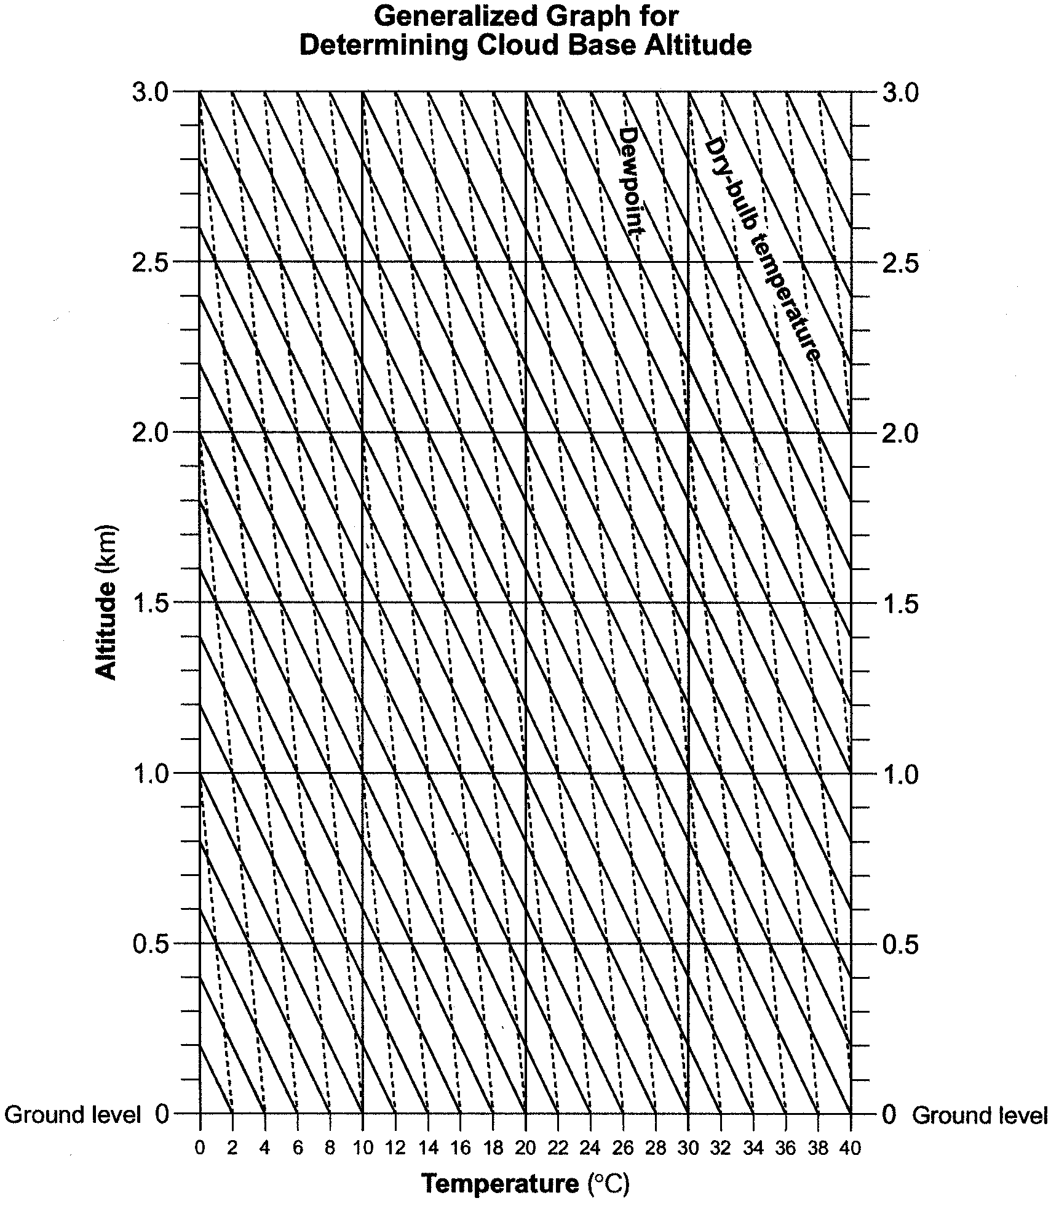
In this lab you will use a graph of temperature and dewpoint lapse rates to help you determine the altitude at which clouds will form.

On a separate sheet of paper define the terms in italics above, you may use a dictionary or any other source of information

Materials:
Sling Psychrometer
Graph for determining Cloud Base Altitude (right)
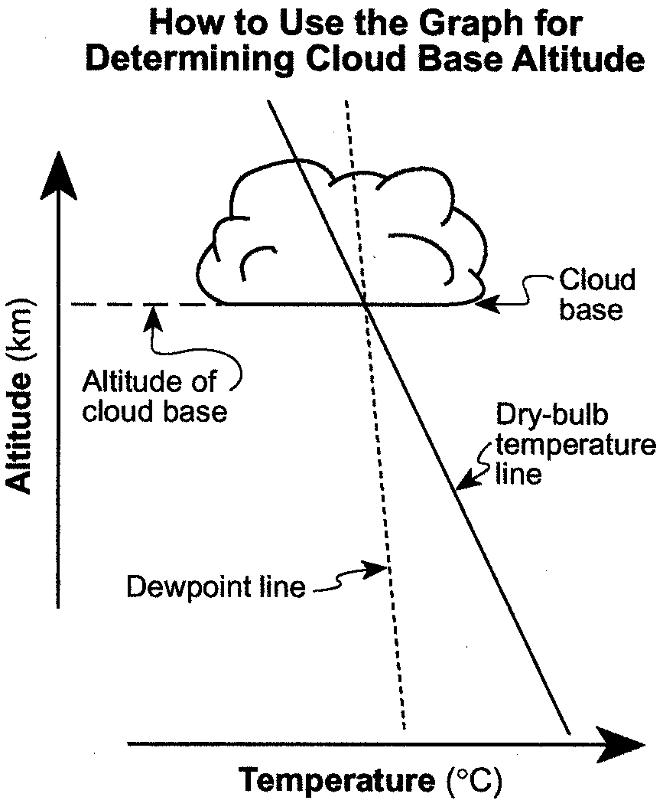
To find the Cloud Base Altitude; find the dry bulb and the dewpoint temperatures on the x-axis of the “Generalized Graph for Determining Cloud Base Altitude”. Follow the solid diagonal lines up from the dry bulb temperature, and the dashed diagonal lines up from the dewpoint temperature. Record the altitude (on the Y-axis) where the dewpoint line crosses the dry bulb line – that is, the elevation at which the dewpoint and the temperature are the same, and net condensation begins.

Use the charts on page 12 of the ESRT and the “Generalized Graph for Determining Cloud Base Altitude” on the pervious page of this lab to fill in the table below.

Dry temp | Wet temp | Difference | Dew-point | Relative Humidity | Cloud Base Alt.
30 | 17
30 | 20
30 | 25
16 | 13
6 | 6

Then answer the following questions:

What are the current conditions in the classroom?
Time ______ Date ______ Temperature ______ Wet Bulb Temp _______ Dewpoint ______
Rel. Humidity ______
Cloud Base ______

What are the current conditions outside?
Time ______ Date ______ Temperature ______ Wet Bulb Temp _______ Dewpoint ______
Rel. Humidity ______
Cloud Base ______

According to the information you read in the introduction, what happens to the air temperature as altitude increases? At what rate? (ºC/km)

According to the information you read in the introduction, what happens to the dewpoint as your altitude increases? At what rate? (ºC/km)

As air rises, which changes faster, the temperature or the dewpoint? How does the graph reveal that?

Imagine that the temperature and the dewpoint at the surface of the earth are approaching each other. What happens to the cloud base altitude as this happens?

What things can happen to bring the temperature and the dewpoint closer together (there is more than one possible answer!).

If there is fog in the air, is the air temperature higher, lower, or equal to the dewpoint temperature – and HOW DO YOU KNOW?

What happens to the volume and temperature of an air mass as it descends (comes down) through the atmosphere?

What would happen to the relative humidity of that air as it descends and why?

