Name:
Regents Earth Science
Severe Weather Lab
Lab Day: Lab Period:
Lab Instructor:

The U. S. Army operated the first national weather service in 1878 - the "observing-sergeants." They were chosen because military discipline would probably secure the greatest promptness, regularity and accuracy. When the civilian national weather service was created in 1890 it was suggested that the name be "Weather Reporting Office of the National Government (WRONG) ☺

Today the National Weather Service (NWS) provides weather, hydrologic, and climate forecasts and warnings for the United States, its territories, adjacent waters and ocean areas, for the protection of life and property and the enhancement of the national economy. NWS data and products form a national information database and infrastructure, which can be used by other governmental agencies, the private sector, the public, and the global community. “Working Together to Save Lives” is the 2003-2008 theme of the NWS.

US Department of Commerce
National Oceanic and Atmospheric Administration
National Weather Service
National Hurricane Center and Severe Storm Forecast Center

The 1995 Hurricane Season.
- The most active Hurricane Season in 62 years.
- Hurricane Allison became the earliest hurricane to form on June 3rd.
- Went down to the "T" named storm for the first time since naming hurricanes.
- Total of 19 Storms, which was the second highest total of all time.
- Total of 11 Hurricanes, which was also the second highest total of all time.
- Five Major Hurricanes of Category Three and better on the Saffir-Simpson Scale.
- Had a total of seven storms during the month of August.
- As many as four storms existed simultaneously in the last week of August 1995.
Plot the following storms on the map of the Atlantic basin, which is enclosed.

Hurricane Allison
Tropical Storm Barry
Tropical Storm Chantal
Tropical Storm Dean
Hurricane Erin
Hurricane Felix
Tropical Storm Gabrielle
Hurricane Humberto
Hurricane Iris
Tropical Storm Jerry
Tropical Storm Karen
Hurricane Luis
Hurricane Marilyn
Hurricane Noel
Hurricane Opal
Tropical Storm Pablo
Hurricane Roxanne
Tropical Storm Sebastien
Hurricane Tanya

The Great Tri-State Tornado
For thousands of residents in Southeast Missouri, Southern Illinois, and Southwest Indiana, the days following March 18, 1925 must have been horrendous. Hundreds of lives had been taken and thousands were injured or left homeless. It would take months to rebuild what had been demolished in less than 4 hours, on that dreadful day of the Great Tri-State Tornado.
It all started around 1:00 p.m. just northwest of Ellington, Missouri, where one farmer was killed. From there, the tornado raced to the northeast, killing two people and inflicting $500,000 in damage upon Annapolis and the mining town of Leadanna. Departing the Ozarks, the storm headed across the farmland of Bollinger County, injuring 32 children in two county schools. By the time the tornado reached the Mississippi River bordering Perry County, eleven Missourians had perished.
The devastation mounted in southern Illinois, as the entire town of Gorham was demolished around 2:30 p.m. There, 34 people lost their lives. During the next 40 minutes, 541 people were killed and 1,423 were seriously injured as the tornado tore a path of destruction nearly one mile wide through the towns of Murphysboro, De Soto, Hurst-Bush, and West Frankfort. In eastern Franklin County, 22 people died as the town of Parrish was virtually wiped off the map. The tornado proceeded unabated across rural farmland of Hamilton and White Counties, where the death toll reached 65.
After taking the lives of more than 600 Illinoisans, the storm surged across the Wabash River, demolishing the entire community of Griffin, Indiana. Next in line were the rural areas just northwest of Owensville, where about 85 farms were devastated. As the storm ripped across Princeton, about half the town was destroyed, with damage here estimated at $1.8 million. Fortunately, the twister dissipated at 4:30 p.m. about ten miles northeast of Princeton, sparing the community of Petersburg in Pike County. In the aftermath, the death toll mounted to 695 people. Property damage totaled $16.5 million—nearly 2/3 of that was in Murphysboro alone.
- 3 states affected (Missouri, Illinois, Indiana)
- 13 counties affected
- ¾ mile average path width (some accounts of 1 mile wide—a record width)
- 73 mph record speed between Gorham & Murphysboro
- Winds in excess of 300 mph
- 28.87" lowest pressure measured on a barograph trace at the Old Ben Coal Mine
- 695 deaths—a record for a single tornado
- 234 deaths in Murphysboro—a record for a single community from such a disaster
- 33 deaths at the De Soto school—a record for such a storm
- 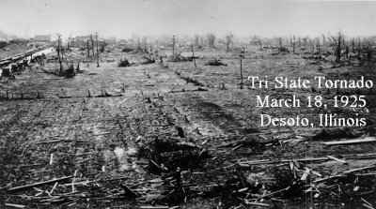2,027 injuries
- 15,000 homes destroyed

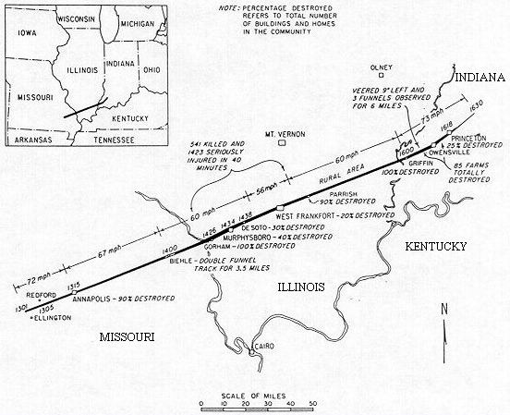

Questions:

- What 3 states were affected by this tornado?
- What is the general direction of travel for this tornado?
- Measure the distance the tornado traveled
- Approximately how many minutes was the tornado on the ground? Convert to hours (hint ÷by 60).
- Determine the tornados rate of movement (distance ÷ time)
- What is the lowest barometric pressure in mb.
- According to the Fujuta Scale determine this tornado’s F rating based upon its pressure, max. width, and wind speeds.

Buffalo Blizzard
Create an isoline map for this famous lake effect storm that paralyzed Western New York

