Name:
Regents Earth Science
Epicenter Location Lab
Lab Day: Lab Period:
Lab Instructor:

Introduction:
As you have learned in class, earthquakes are vibrations caused by large releases of energy. These energy releases can occur as a result of fault movements, asteroid impacts, volcanic eruptions, and movements of magma, as well as by explosions. As a result, vibrations can begin both in and on the Earth’s crust. The energy released radiates away from the point of origin, the focus. Commonly, when describing the location of an earthquake, scientists and the media often talk about the earthquake’s epicenter, the point on the Earth’s surface directly above the focus.
Earthquake energy can be recorded on a seismograph, producing a seismogram. Seismographs can “pick up” several types of energy waves, which travel through the Earth, and radiate in all directions from the focus. Two of these waves are used to locate earthquake epicenters:

- “P”-waves or longitudinal waves: “P” stands for primary. These waves travel fastest and arrive at seismographs first. They are compressional (“push-pull”) waves.

- “S”-waves or transverse waves: “S” stands for secondary. These waves travel more slowly and arrive at seismographs after P-waves. They are perpendicular (“side-to-side”) waves.

As you may recall, we use travel time graphs (Figure 3) to show how long it takes each type of seismic wave to travel a distance, measured on Earth’s surface. The difference between the S-wave arrival time and the P-wave arrival time corresponds to the distance of the seismograph from the focus of the earthquake. However, these waves can arrive at a seismograph from any direction! Thus, one seismograph is not enough to determine the epicenter of an earthquake. A second seismogram, recorded in a different location, can narrow down the possible location to some degree, but at least three seismograms are required in order to accurately plot the epicenter.

In this lab, you will use seismograms from three locations to determine the epicenter of an earthquake- Alaska, North Carolina, and Hawaii. You will use the P- and S-wave arrival time difference to determine distance to epicenter, then use a compass to record the distance radius measured by each station. Remember, accuracy is important- take care to make accurate measurements!

Materials:
  - 3 seismograms from the same earthquake
  - Safe drawing compass
  - P- and S-wave travel time curve
  - Map for plotting the earthquake epicenter
  - Straight edge

Procedure:

1. Examine Figure 1, which shows seismograms of an earthquake recorded at three stations in Alaska, North Carolina, and Hawaii. Note that the first set of zigzags at each city indicate the arrival of P-waves, and the second set of zigzags indicate the arrival of S-waves. Draw a straight line connecting the initial start of each P- and S-wave down to the time axis.

2. Estimate to the nearest ten seconds, the times of the first arrival of the P-waves and S-waves at each station in Figure 1. Then, subtract the S minus P:

 | First P arrival | First S arrival | S-P

Sitka, AK
Charlotte, NC
Honolulu, HI
2. Now use the S minus P times and the P- and S-wave Travel Time Curve to estimate the distance from the epicenter for each location. Refer to the following procedure to accomplish this:

- Lay a strip of blank paper along the time axis of the Travel Time Curve (Figure 3). Mark two dots on the edge of the paper corresponding to the S-P time difference calculated for the first location above.
- Keeping the edge of the paper parallel to the vertical lines on the graph, slide the paper along the S and P curves until the two dots lie exactly on the S and P curves.
- A vertical line through the S and P curves at these points should intersect the horizontal axis. This is the distance between the seismograph at this location and the earthquake’s epicenter.
- Record this distance in the table below.
- Repeat this procedure for the next two S-P times.

SEISMOGRAPH LOCATION | DISTANCE to EPICENTER
Sitka, AK | kilometers
Charlotte, NC | kilometers
Honolulu, HI | kilometers

3. Next, find the earthquake’s epicenter, using the distances just obtained and the procedure below.

a. First locate and mark the three seismic stations on the world map (Figure 2).
Sitka, AK: 57° N latitude, 135° W longitude
Charlotte, NC: 35° N latitude, 81° W longitude
Honolulu, HI: 21° N latitude, 158° W longitude

b. Using a drawing compass, make a circle around each seismic station. Make the radius equal to the distance between the station and the epicenter, as determined in Question 2. Using the scale in Figure 2 to set this radius on
your compass. The circles you should draw should intersect near one point. This point is the epicenter.

Interpretation:

1. What is the origin time of the earthquake (at what time did the earthquake occur)? ________________________

2. Which seismograph recorded the earliest P-wave arrival? The latest? _________________ ______________

3. What does the difference described in #2 suggest about the relative locations of each seismograph?

____________________________________________________________________________________________

____________________________________________________________________________________________

4. New York City is located at roughly 41º N latitude and 74 º W longitude. How far is this from the epicenter?

____________________________________________________________________________________________

5. What time would the P-wave from this earthquake have reached New York, NY? _________________________

6. Your circles may not have intersected precisely at one point. What are the possible reasons for this.(be specific!)

____________________________________________________________________________________________

____________________________________________________________________________________________

____________________________________________________________________________________________
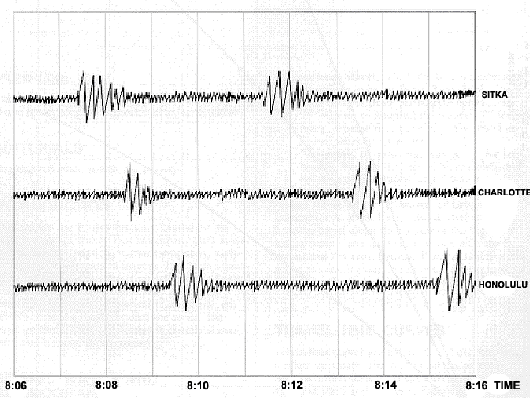
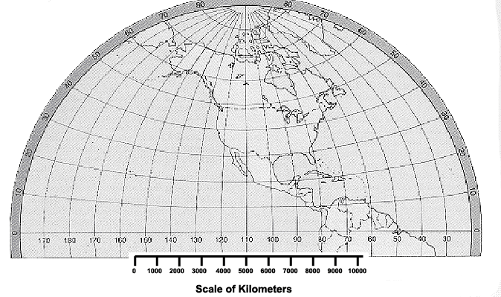
Figure 1. Seismograms recorded at 3 different locations for a single event. Times are EST.
Figure 2. Partial World Map for plotting epicenter.

Figure 3.

