Name:
Regents Earth Science

Stratigraphy Lab
Lab Day: Lab Period:
Lab Instructor:________________________
Introduction:
The Finger Lakes Region of New York State is underlain by rocks of Devonian Age. Use your reference tables to determine the types of rocks that outcrop around the Finger Lakes:

The rocks include __________________________________________________________

Patterns of deposition and the existence of various fossils indicates that these rocks were deposited in a shallow sea that covered much of the central United States during that time. Over 1200 meters (that’s about ¾ of a mile!) of sedimentary rocks are deposited in the Devonian of upstate New York. We can see continuous outcrops of over 100 meters of thickness in quarries (where stone is mined for building materials), in road cuts, and where rivers have cut deep gorges into the rocks. No one, however, has found a place where the entire 1200 meters exists in a single outcrop. How do you suppose geoscientists form a complete view of these rocks?

Imagine for a moment that you have several Earth Science books, each with large sections of pages missing. If, among the many pieces you had, there were some “overlapping” pages, you might be able to reconstruct a complete book from the pieces. Geoscientists do this with rock outcrops. They try to find similar rocks that overlap in different outcrops in an attempt to match them up, or correlate them.

In this lab you will correlate nine different outcrops from the area around Lake Cayuga to develop a complete 14 inch thick model of the rock layers (or STRATIGRAPHIC COLUMN) of the Devonian in that area. Each inch of your model represents about 10 meters of outcrop. The table below describes the actual rock units that outcrop in that area.
ROCKS OF THE LAKE CAYUGA BASIN, NEW YORK
FORMATION | DESCRIPTION
Sherburne Shale | Shale at bottom with increasing sand toward top
Geneseo Shale | Black Shale about 10 meters thick
Tully Limestone | Limestone about 3 meters thick
Moscow Shale | Shale with limestone base about 15 meters thick
Ludlowville Shale | Shale, about 25 meters thick
Skaneateles Shale | Shale with limestone cap, about 28 meters thick
Marcellus Shale | Mostly shale, black at base, then thin limestone, 4 meters of limestone at top. About 25 meters thick
Onandaga Limestone | Highly fossiliferous limestone over 25 meters thick
Oriskany Sandstone | Thin sandstone about 1.2 meters thick
Manlius Limestone | Finely layered limestone about 7.6 meters thick
Rondout Dolostone | Dolostone about 7.5 meters thick
Procedure:
You’ve learned that SUPERPOSITION is an important concept when interpreting the rock record. It’s important to know which way is up! Each of the outcrops drawn on the next page are marked with the letter “T” at the top of the outcrop.

1. Using a scissors (no running, throwing, dueling, carefully cut out the nine outcrops.
2. Lay the outcrops out on your desk and correlate the rocks in one outcrop with those of the others. You will find that the patterns in the layers are most useful and that fossils are sometimes useful and sometimes misleading. The rock descriptions in the table above will probably be helpful.
3. When you’ve got all the layers matched up, acquire your instructor’s initials then tape them together.

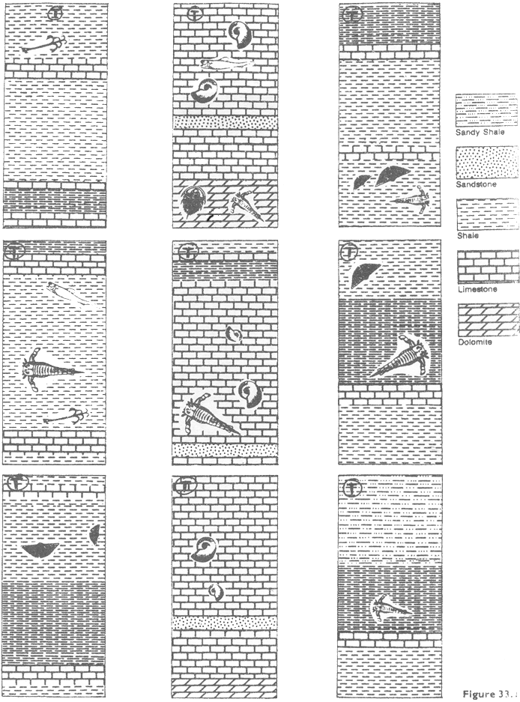

ANSWER THE FOLLOWING QUESTIONS COMPLETELY AND NEATLY BELOW:

- Which 3 formations are entirely limestone?
- Which formations are entirely shale?
- Which formation most likely was once a beach?
How do you know?
- The Tully limestone stands out as a ridge of rock between valleys developed on the Moscow and Geneseo formations. What might account for this landscape pattern?

- Which is deposited closest to the shore of a sediment collecting basin: Sandstone, siltstone, or clay?

Explain

- Look at the description of the Sherburne. How was the distance to (or from) the shore of the sea changing in this area as the Sherburne was being deposited? Explain!

- The Onandaga contains a few thin layers of volcanic ash. Why is volcanic ash useful for correlating layers of sedimentary rock? (see your text if you don’t remember or can’t figure it out)

- The Onandaga also contains fossils of crinoids, coral, trilobites, and brachiopods. Why are there no fossil ferns or primitive pine trees?

- Why are the Eurypterids (see the reference tables) in these cross sections not useful as index fossils?

- Of what use are INDEX FOSSILS to historical geologists? (see your text!)

