Name:
Regents Earth Science

Eratosthenes Lab
Lab Day: Lab Period:
Lab Instructor:

Background:
Eratosthenes, a Greek geographer (about 276 to 194 B.C.), made a surprisingly accurate estimate of the earth's circumference. He set up a vertical post at Alexandria and measured the angle of its shadow when the well at Syene was completely sunlit. Eratosthenes knew from geometry that the size of the measured angle equaled the size of the angle at the earth's center between Syene and Alexandria. Knowing also that the arc of an angle this size was 1/50 of a circle, and that the distance between Syene and Alexandria was 5000 stadia, he multiplied 5000 by 50 to find the earth's circumference. His result, 250,000 stadia (about 46,250 km), is quite close to modern measurements
Set up:
$$\frac{∠a}{\text{360}°}=\frac{\text{disance}}{\text{circumference}}$$

A. To get $∠a$ we will be using the Eartosthenes stick. A (solar) noon time measurement is key for accuracy. Drive the stick into the ground to the marked line. This should make the distance from the ground to the top of the stick 120 cm. Make sure the stick is ‘plumb’ or pointing to the center of the earth. Place a Popsicle stick in the ground where the top of the Eartosthenes stick’s shadow hits the ground. Now measure the angle that is formed from the shadow and the Eartosthenes stick. Do this by eyeballing the angle with a protractor.
$∠a$=

You can also figure this out by measuring the distance from the Popsicle stick to the Eartosthenes stick and applying it to this Trigonometry formula. Divide the 120cm height of the Eartosthenes stick by the distance of its shadow. Then take the inverse tangent of that number. This is your angle. Compare this to your eyeball estimation using the % error equation.
$∠a$ (trig) =
$${\text{tan}}^{−1}=\frac{\text{shadowlength}}{\text{120}\text{cm}}$$
% error =

To make the math simple we will use the distance to where the solar noon equals the zenith of the observer. This of course depends on today’s date. The distance to 0⁰ shadow angle for today is km.

Substitute and Solve!
$$\frac{}{\text{360}}=\frac{}{\text{Circumference}}$$
C =
The actual distance is 40,008 km. What is your % error? (do math here)
% error =

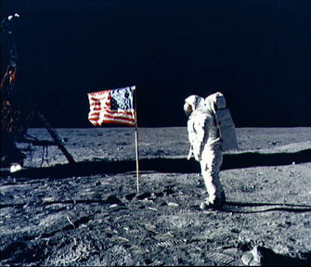
B. Does this work for other planets and moons too?

Sure it does! Lets assume the following picture of the Apollo 11 flagpole is 7 feet tall and the angle the shadow is at 36.8⁰ and the distance is 660 miles to where the shadow angle is 0⁰.

Do math here (start with the formula)

C. Measure the angle on the following picture.
Measure the distance between the rays.
Solve using Erathosthenes’ method.

Discussion questions

- What must we assume about sun rays for this experiment to work?
- If we measure the angle to be too big what happens to the circumference when we plug it into the equation?

  - Did Eratosthenes measure the equatorial or polar circumference?
  - What is the difference?
  - What is the correct geometrical shape of the earth?
  - As seen from outer space can this difference be seen?
  - So what does the earth’s shape appear to be like (use some example from your every day life like an egg, a pear, fishing pole)

