Name:
Regents Earth Science
Topographic Map Exercises
Lab Day: Lab Period:
Lab Instructor:

You will be handing in this sheet completed as well as four tracings.

Up close and personal with your map
  - What is the name of your Quad:
  - What is the scale of the map:
  - What is the contour interval of the map:
  - Is Rt. 77 an Interstate, US, or State road:
  - Shade in the area your map covers on New York State map below
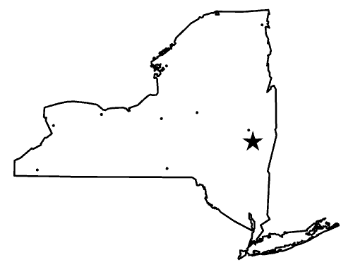

Map features

- Give an accurate latitude, longitude reading for Divers Lake:
- Trace the area around the school (including the contours), as well as the airport. Is the airport on a steep slope (how do you know?)
- Trace the area around The “Gravel Pit” which can be found East of Scotland and South of Martin roads. Why do you suppose it is filled with water?
- Trace the hill at the end of Hillert Road in the Wildlife Refuge. Give the max elevation of this hill:
- Trace the area around Indian Falls Lake including Tonawanda Creek. What direction do the “v’s” point?
- Determine the overall gradient of the Conrail Tracks from the town of Basom (Rt. 77) to the Village of Akron (the access road near Evergreen Cemetery) Show all work here.

