Name:
Regents Earth Science
Retrograde Loop Lab
Lab Day: Lab Period:
Lab Instructor:
A. Graphing the loop
The following table gives the location in the night sky of Mars for various dates in 1970 - 71 when retrograde motion occurred. Plot all of the points from the table on the graph of figure 1. Indicate the points that represent the dates shown with an asterisk (*) on the graph. This will help you to connect the points in the correct order.
Date | R.A |  | DEC.
Date | h | m | d | m
11 Oct | 8 | 5 | 21 | 49
21 Oct | 8 | 26 | 20 | 54
31 Oct* | 8 | 46 | 19 | 58
10 Nov | 9 | 3 | 19 | 2
20 Nov | 9 | 19 | 18 | 12
30 Nov | 9 | 31 | 17 | 31
10 Dec | 9 | 41 | 17 | 4
20 Dec* | 9 | 47 | 16 | 56
30 Dec | 9 | 48 | 17 | 11
9 Jan | 9 | 45 | 17 | 50
19 Jan | 9 | 37 | 18 | 51
29 Jan* | 9 | 23 | 20 | 3
8 Feb | 9 | 8 | 21 | 13
18 Feb | 8 | 52 | 22 | 5
28 Feb | 8 | 39 | 22 | 33
10 Mar* | 8 | 32 | 22 | 35
20 Mar | 8 | 31 | 22 | 17
30 Mar | 8 | 34 | 21 | 42
9 Apr* | 8 | 41 | 20 | 52
19 Apr | 8 | 52 | 19 | 59
29 Apr* | 9 | 5 | 18 | 34
9 May | 9 | 21 | 17 | 6

Figure 1. Plot the graph from A.
Remember that there are sixty seconds of time in one hour and sixty minutes of arc in one degree. You can round to the nearest five minutes when plotting.
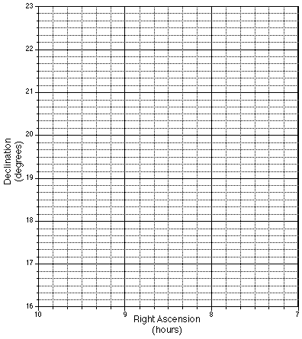

Questions for part A.
1. Does Mars always move through the sky at the same rate?
2. About how long did it take for Mars to complete the loop?
3. During the loop, how much of the time was spent in retrograde motion?

Figure 2.

Geocentric Explanation
In the geocentric system, Earth is at the center of a series of circles. The simplest model to illustrate the motion contains epicycles. Imagine a ball rolling around a big wheel. Suppose the ball is transparent and has a black dot painted on it. How would the dot appear to move if viewed from the center of the circle? Draw a diagram that illustrates how epicycles could produce retrograde motion in the space to the right.

Heliocentric Explanation
Figure 3 shows the actual orbits of Earth and Mars around the sun. With a ruler connect the corresponding points in the orbits of Earth and Mars by lines. Extend the lines to intersect the vertical line at the right. Number these intersection points on the vertical line following the example.

Figure 3. Draw the lines for part B here.
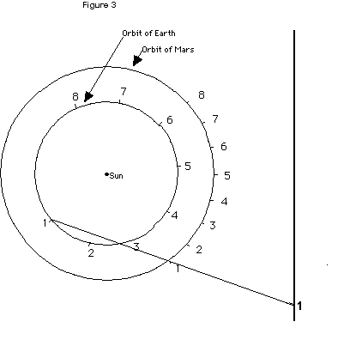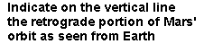

Questions for part B.
1.What do the numbered lines represent?
2. Without additional information (using only the path of Mars on the graph in Figure 1) could you tell which of these two models really explains retrograde motion as we see it? Explain briefly.

