REGENTS EARTH SCIENCE

LAB MANUAL

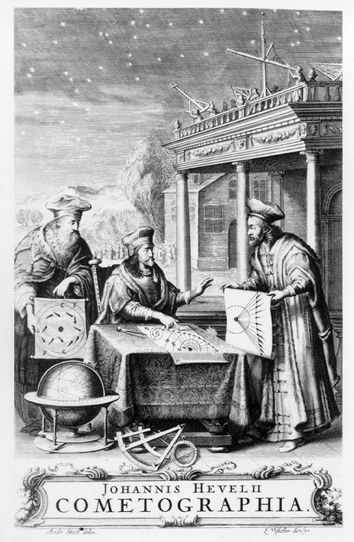
2007-2008

Name:
Regents Earth Science

Lab Checklist
Lab Day: Lab Period:
Lab Instructor:

1st quarter
- _____ Check in & Safety
- _____ Metric Measurement & SI Units
- _____ Density of Solids
- _____ Density of Liquids
- _____ Solar Observations
- _____ Reading Topographic maps
- _____ Minerals
- _____ Igneous Rocks
- _____ Sedimentary Rocks
- _____ Metamorphic Rocks

2nd quarter
- _____ Physical Weathering
- _____ Chemical Weathering
- _____ River Discharge
- _____ Stream Tables
- _____ Deposition of sediments
- _____ Plate boundaries
- _____ Epicenter location
- _____ Virtual Earthquake
- _____ Seafloor spreading
- _____

3rd Quarter
- _____ Stratigraphy
- _____ Radioactive Decay
- _____ Conduction
- _____ Convection
- _____ Radiation
- _____ Dew point, humidity & clouds
- _____ Weather Patterns
- _____ Weather Patterns
- _____ Severe Weather
- _____ Severe Weather

4th quarter
- _____ Eratosthenes method
- _____ Graphing a retrograde loop
- _____ Ellipses
- _____ Solar system model
- _____ HR Diagram
- _____
- _____
- _____
- _____
- _____ Regents Lab Exam

All labs due:

Note to student: All labs must be in your lab folder, with a passing grade in order to participate in the Lab Performance Final (part D). Failure to do so will exclude you from the Regents Exam in June.

Name:
Regents Earth Science
Lab Check In & Safety
Lab Day: Lab Period:
Lab Instructor:

Pre-test (circle your answer)
- T F It is okay to eat, drink, or chew gum in Lab Class.
- T F You will always have to wear safety goggles in lab class.
- T F Its your responsibility to make up any missed work due to sickness or absenteeism.
- T F If you miss lab come in ASAP so the materials will still be available.
- T F If you fail Earth Science Lab you fail the entire year for Earth Science Class too.
- T F Inappropriate behavior is encouraged in Lab class.
- T F Bring your required materials to class when you feel like it.
- T F Lab will help you understand the material you are covering in class.
- T F Working with a partner is okay.
- T F Cheating is encouraged.

Safety check off
  - Fire exits
  - Fire pull station
  - Phone 9-911
  - First aide – Tell your instructor

Required Materials to bring to class
- Pencil & pen
- Calculator (Scientific)
- Lab Folder (two pocket any color)
This will stay in Room 221 never to leave again!
    - Eye wash
    - Fire blanket
    - Fire hood
    - Fire extinguisher
    - Shower
    - Sharps
  - Clothing
    - Eye wear
      - goggles
      - contacts
    - Clothing – we go outside on a moments notice even if its cold
    - Footwear
    - Gloves
    - Aprons

Labs are graded on a 10 point scale. They are due the next Lab day before class starts. Often you will not have time to finish. This means you need to arrange to finish either during a study hall or after school. Scores ≥ 7 are passing. 6 and below are considered unsatisfactory and needs to be corrected to earn a satisfactory mark. ALL lab reports must be completed before you take the final exam. Failure to complete your labs will keep you from taking the written portion of the exam resulting in failure of the entire course.

The last day to complete your labs is May , 2008.

