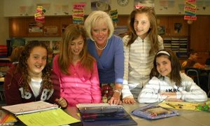
2008 Time Warner Cable National Teacher Award Winner: Sandra Keppel, Akron MS ELA Teacher

Time Warner Cable, the second largest cable television operator and provider of telecommunications services, announced May 1st that Sandra Keppel, Grade 6 ELA teacher has received a 2008 Time Warner Cable National Teacher Award.

In addition to $2,000 cash grant and a $3,000 technology grant for the Akron Middle School will be honored during an awards event in Washington, DC on June 3, 2008. Keppel is just one of 15 educators from across the country selected for this prestigious award for creating a winning classroom project.
The award winning entry, “Beep! Beep! Road Runner Research and Enrichment,” allowed students to explore the power of using project-based learning that encompass Distance Learning to enhance Critical Thinking Skills and create authentic assessment tools. Cable resources such as Animal Planet, National Geographic, The Discovery Channel, and Road Runner high speed Internet technology enable students to connect to the Buffalo Zoo via the DLL.
Students were empowered to write research reports, podcasting scripts, blogs that address higher-order thinking skills of synthesis and evaluation, as well as create their own web pages. Enrichment toys for the zoo animals were designed using computer technology. The multiple uses of technology support a broad scope of learning standards essential to raise state scores and which really motivates all students to be in charge of their own learning with classroom to community activities for real audiences.
Gordon Harp, President of Time Warner Cable's Buffalo Division, expressed his heartiest congratulations to Mrs. Keppel in his notification letter, "Your dedication, creative energy and enthusiasm are clear in the work submitted for this recognition. Your students are fortunate to have you as their teacher and we are proud to support you in these efforts."

