Parameters for Setting Growth Targets & Calculating Achievement Scores

SETTING GROWTH TARGETS for SLOs - State 20% and/or Local 20%

For the State 20%, teachers will use the SLO target setting process to determine their points. All teachers will write growth targets using the same format:
OPTION #1: 75% of students will meet their individual targets on the post-assessment.

Parameters for setting individual targets
- targets should be set so that students reach proficiency -> Level 3 or higher, 65% or higher*
*in special circumstances, targets may be set lower if the data supports it
- can use proficiency or growth targets [see pg. 16-18 in SLO workbook]

OPTION #2: 75% of students will meet tiered targets on the post-assessment.

Parameters for setting tiered targets
- 2 - 3 tiers for targets where students reach proficiency
  - Example: Group#1 = 85%/Level 4, Group#2 = 65%/Level 3, Group#3 = 55%/Level 2*
*in this example a lower target was set for high risk students based on baseline data
- can use proficiency or growth targets [see pg. 16-18 in SLO workbook]

CALCULATING ACHIEVEMENT SCORES - Local 20%

For teachers who are using the same assessment for both the State 20% and Local 20%, the percentage of students who scored a Level 3 (65%) or higher on the post-assessment will be put into the HEDI chart below to determine the number of points out of 20 for the Local 20%.
The following achievement calculation will be made:
___ % of students that scored a Level 3 (65%) on the post-assessment.
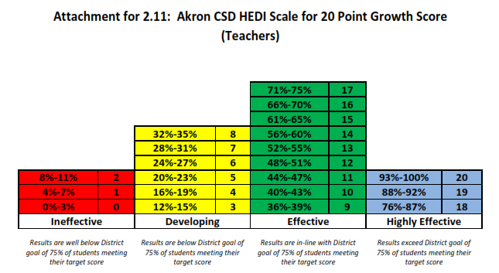
75% is the district goal for all teachers.
This % is put into the HEDI scale to get the 20 point score.

Elementary School Target Setting Parameters

K-2 Common Branch [ELA & Math]
STATE 20 | LOCAL 20
- 75% of students will meet their individual/tiered targets on the Akron CSD-developed ___________ Assessment. | - 75% of students will meet their individual/tiered targets on the STAR assessment.  - achievement and/or growth

3 Common Branch [ELA & Math]
STATE 20 | LOCAL 20
- 75% of students will meet their individual/tiered targets on the NYS 3rd grade State Assessment. | - 75% of students will meet their individual/tiered targets on the STAR assessment.  - achievement and/or growth

4-5 Common Branch [ELA & Math]
STATE 20 | LOCAL 20
- STATE PROVIDED GROWTH SCORE | - 75% of students will meet their individual/tiered targets on the STAR assessment.  - achievement and/or growth

Specials Teachers [PE, Art, Music]
STATE 20 | LOCAL 20
- 75% of students will meet their tiered targets on the Akron CSD-developed ______ Assessment. | - ____% of students who score a Level 3 (65%) or higher on the Akron CSD-developed ____________ Assessment.

Reading
STATE 20 | LOCAL 20
- 75% of students will meet their individual targets on the AIMSweb assessment. | - 75% of students will meet their individual/tiered targets on the STAR assessment.  - achievement and/or growth

Middle School Target Setting Parameters

6-8 ELA or Math Teachers
STATE 20 | LOCAL 20
- STATE PROVIDED GROWTH SCORE | - 75% of students will meet their individual/tiered targets on the STAR assessment.  - achievement and/or growth

8 Science Teachers
STATE 20 | LOCAL 20
- 75% of students will meet their tiered targets on the 8th Grade State Science Assessment. | - 75% of students will meet their tiered targets on the Akron CSD-developed 8 Science Assessment. (Locally chosen portion of the NYS Science Assessment)

6-8 Teachers with District-Developed Assessments [Social Studies, Science 6-7, LOTE, FACS, Tech, Art, PE, Music, etc.]
STATE 20 | LOCAL 20
- 75% of students will meet their tiered targets on the Akron CSD-developed ______ Assessment. | - ____% of students who score a Level 3 (65%) or higher on the Akron CSD-developed ____________ Assessment.

High School Target Setting Parameters

HS Teachers with a District-Developed Post-Assessment
STATE 20 | LOCAL 20
- 75% of students will meet their tiered targets on the Akron CSD-developed ______ Assessment. | - _____% of students score a 65% or higher on the Akron CSD-developed ______ Assessment.

HS Teachers with a NYS State Regents
STATE 20 | LOCAL 20
- 75% of students will meet their tiered targets on the NYS ______ Regents Exam. | - _____% of students score a 65% or higher on the NYS ________ Regents Exam.

